Chapter 16, Problem 40.

In the circuit of Fig. 16.63, find v(t) and i(t) for t > 0. Assume v(0) = 0 V and
i(0) = 1 A.

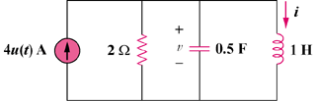

Figure 16.63
For Prob. 16.40.

